Project JournalDaily NASA Dashboard



Parth Parashar   
Starting Date: - 2nd November, 2021

# Project Introduction

Daily NASA Dashboard is a Dashboard/ Front-end project about Information on Astronomical Objects and their features. This Dashboard will contain information fetched from the NASA API like Image of the day, Weather on Mars, images from mars etc.

The Daily NASA Dashboard will contain information about the following astronomical objects: -

1. Planets
2. Meteors
3. Asteroids
4. Galaxies
5. Sun
6. Photos of the astronomical objects
7. Picture of the day fetched from the NASA apod API
8. Live images from Mars Rover using NASA Mars Rover Photos API
9. Live weather from Mars using NASA API
10. Near Earth objects using Asteroids NeoWs API

# Beginning: -

1. 2nd November 2021: -

The first step taken towards building the dashboard is to start working on the homepage.

The technologies that are going to be used are HTML and CSS.

The Home page of the Dashboard will be divided into two parts: -

The first part would be the Navigation Bar that will act as a quick link bar to the important stuff like links to the Photos fetched from the NASA APIs etc.

The second part of the home page will contain the links in some form to the various astronomical objects and information about them.

The things we will need are : -

1. Github link
2. VS Code
3. HTML and CSS files
4. 3rd November 2021

Created the home.html and home.css page and decided upon the structure of the project

Finalised topics are as follows: -

1. Planets
2. Meteors
3. Asteroids
4. Galaxies
5. News
6. Magazine
7. Photo of the day
8. Mars Rover Pictures

3) 5th November 2021

I have started working on the home page and while the wireframe of the home page has already been decided as given below:-

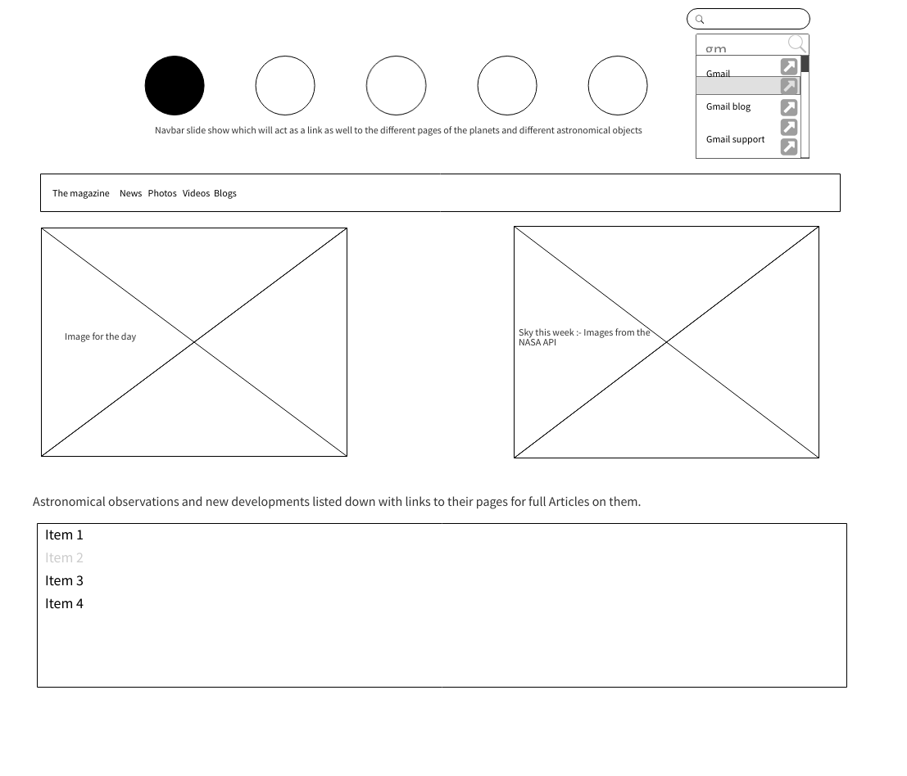

Created the home.html and home.css file. Here, the basic structure of the file has been added.

I have written the code for a basic navigation bar with borders.

The navigation bar right now contains only the basic operations like links to Magazines, News and Photos.

Issue faced: -

The alignment of the navigation bar was off and to set this, I had to use the text-align property of the enclosed div to align it properly.

4) 6th November: -

So the Navigation bar that had been created yesterday was a basic navigation bar and needed to have properties like hover, active etc.

Added these properties to the navbar.

Also, We need to incorporate several other links to pages on the Home page. So, I had to study what can be done to have those links to the other pages.

There are plenty of ways to do so.

The feasible options which I think are a good fit for our project are

1. Sliders with links in images
2. Div elements and arranging those Grid elements
3. Grid of images with links embedded in the images

Among these, I found that the slider feels to be the most natural option because of the way we can make the application look by manipulating different properties of the slider using CSS.

Some of the links that can be used for understanding the sliders are mentioned below: -

<https://www.geeksforgeeks.org/how-to-create-a-working-slider-using-html-and-css/>

[You can get pretty far in making a slider with just HTML and CSS](https://css-tricks.com/can-get-pretty-far-making-slider-just-html-css/)

<https://pagepro.co/blog/how-to-build-a-slider-without-javascript/>

5) 7th November

Started Implementing the slider using HTML and CSS.

Have started building the basic slider with images as slides.

The first thing that I did is to have the basic slider in place and then I will add the images to the slides so that we can have a basic home Page layout with us, upon which we can build the application further.

**Difficulty: -**

So I am trying to implement the slider without the use of Javascript or jQuery or any other DOM specific libraries, it is getting difficult to get the slides to move and transform according to our requirements.

The slides are remaining static at one place. Will need to come up with something

**Solution: -**

To overcome this situation, I found a solution on the website: -

<https://pagepro.co/blog/how-to-build-a-slider-without-javascript/>

On this website, they are using the CSS properties such as transform and transition to give the effect of a moving slider.

6) 8th November: -

Implemented the CSS transform and transition properties to the slider.

Also added the links to the images as an internal tag to the images tag in html.

**Difficulty: -**

When the transform and transition properties were added, they needed to be added to the sliders.

I was adding those only to the main divs i.e dic of the entire slider. This led to faulty results in such a way that the slides of the slider become very large and they started covering the entire screen

**7)** 9th November

The problem of the slider covering the entire div and not sliding forward still persists.

I have tried a bunch of different combinations of things to rectify this like changing the margins and paddings but to no avail.

8) 10th November

The problem of the slider has been resolved. The reason for the slider covering the entire div element was because the position of the image had to be relative and not fixed. This way, CSS would be able to have a better control over the image and the results would be as desired. Along with this, the overflow has to be hidden to have the expected results.

While this slider has the basic functionality of links, It is not looking as good as it should as it only has Navbar and slider which is also not covering a lot of portion of the home Page and the home page looks a little too basic.

9) 11th November

The sliders need to have better visual appearance and for that, I started looking on some youtube tutorials mentioned below: -

<https://www.youtube.com/watch?v=pGHOaY4dhAA>

<https://www.youtube.com/watch?v=0wvrlOyGlq0>

<https://www.youtube.com/watch?v=Cbhp2NL_p1Y>

The third link here is a very good example of how we can best use the slider.

Started implementing the changes.

10) 12th November

Implementing the slider changes.

Difficulty: -

Implementing the slider to have this functionality is a difficult task.

The slider keeps on messing around the borders and also the relative positioning becomes difficult for the hover expansion effect.

Solution: -

I addressed this problem by adjusting the “viewports” for the slider’s individual elements. The adjustments which i did were :-

display: block;

position: relative;

perspective: 100vw;

margin: 0 auto;

width: 100%;

max-width: 380px;

This solved the border problems and the slides were discreet and not intertwining with each other

But this led to another problem and that is the images are not coming in the form of squares and not having any 3d effect (i.e in the form of small floating boxes). This in technical terms is called the carousel effect.

In the meantime, Vivian has created the github repository for the project and has started working on the Mars live rover feed.

11) 13th November

Now, for the slider to work as desired, it needs to have the 3d effect as well as on click functionality to take the user to another link.

For having 3-D effect, we need to have the following properties,

1. For the viewport:-

transform-style: preserve-3d;

z-index: 0;

1. For the container: -

transform-style: preserve-3d;

1. For slider items: -

transform: translate3d(0, 0, 0) rotateY(45deg);

After this, we will have square slides where we can have images/ text as the sliders.

Difficulty: -

Now after this has been implemented, there has to be a mechanism to actually have the slides move to the left/ right and expand on click of the user. But, This is a problem to achieve without the use of javascript or some form of Javascript.

12) 14th November

Now that we have solved the problem of having the correct shape of the slider as well as the correct 3-D form of the slider, the problem we faced yesterday was to actually move the slides.

I tried a bunch of things to resolve this problem like the use of transformX and TransformY but to no avail.

There needs to be a link between the transform values of the slides so that they work in sync.

There is no significant progress on this front as of now.

13) 15th November: -

While the problem of slides is still persisting, I have created some new files pertaining to Planets as well as Image of the day to be fetched from the NASA API. These contain only the basic HTML and CSS layouts.

Watched a bunch of videos for the slider issue. The links for them are mentioned below: -

<https://www.youtube.com/watch?v=sOvvuU9knBA>

<https://www.youtube.com/watch?v=yirix3tA61Q>

<https://www.youtube.com/watch?v=CNvSlr9AzN8>

14) 16th November: -

The videos I watched yesterday gave me an idea of not treating the slides as single elements but to treat them as different elements and then putting them together.

This way, I could access the slides using the element properties in the CSS file and have the control over the bigger divs as well.

Solution to the slides problem: -

We can have the different divs and the slides categorised in two categories: -

1. Before
2. After
3. Apart from this, the slides will also have the trigger state defining how they will function on trigger and what triggers them

For the before state: -

1. Slide elements

transition: transform 0.3s cubic-bezier(0.62, 0.28, 0.23, 0.99) 0.15s;

transform: translate(-24px, 12px);

box-shadow: 0 14px 28px rgba(0, 0, 0, 0.25), 0 10px 10px rgba(0, 0, 0, 0.22);

1. Slides inner items:-

background-image: linear-gradient(90deg, rgba(0, 0, 0, 0) 0%, #000 50%, rgba(0, 0, 0, 0) 100%);

background-repeat: repeat-x;

background-size: 200% 100%;

background-position: 0% 0%;

transition: background-position 0.3s linear;

1. Slide property for the transition state

.wgh-slider-target:nth-of-type(8):checked ~ .wgh-slider__viewport .wgh-slider-item:nth-child(8), .wgh-slider-target:nth-of-type(7):checked ~ .wgh-slider__viewport .wgh-slider-item:nth-child(7), .wgh-slider-target:nth-of-type(6):checked ~ .wgh-slider__viewport .wgh-slider-item:nth-child(6), .wgh-slider-target:nth-of-type(5):checked ~ .wgh-slider__viewport .wgh-slider-item:nth-child(5), .wgh-slider-target:nth-of-type(4):checked ~ .wgh-slider__viewport .wgh-slider-item:nth-child(4), .wgh-slider-target:nth-of-type(3):checked ~ .wgh-slider__viewport .wgh-slider-item:nth-child(3), .wgh-slider-target:nth-of-type(2):checked ~ .wgh-slider__viewport .wgh-slider-item:nth-child(2), .wgh-slider-target:nth-of-type(1):checked ~ .wgh-slider__viewport .wgh-slider-item:nth-child(1) {

For the After state

1. Inner elements

top: 0;

left: 0;

width: 100%;

height: 100%;

z-index: 1;

background-image: linear-gradient(90deg, rgba(0, 0, 0, 0) 0%, #000 50%, rgba(0, 0, 0, 0) 100%);

background-repeat: repeat-x;

background-size: 200% 100%;

background-position: 0% 0%;

transition: background-position 0.3s linear;

display: block;

position: absolute;

content: "";

1. Slider container

position: absolute;

top: 0;

left: 0;

bottom: 0;

right: 0;

transition: transform 0.3s cubic-bezier(0.62, 0.28, 0.23, 0.99) 0.3s;

transform-style: preserve-3d;

1. Slide property

.wgh-slider-target:nth-of-type(8):checked ~ .wgh-slider__viewport .wgh-slider-item:nth-child(8), .wgh-slider-target:nth-of-type(7):checked ~ .wgh-slider__viewport .wgh-slider-item:nth-child(7), .wgh-slider-target:nth-of-type(6):checked ~ .wgh-slider__viewport .wgh-slider-item:nth-child(6), .wgh-slider-target:nth-of-type(5):checked ~ .wgh-slider__viewport .wgh-slider-item:nth-child(5), .wgh-slider-target:nth-of-type(4):checked ~ .wgh-slider__viewport .wgh-slider-item:nth-child(4), .wgh-slider-target:nth-of-type(3):checked ~ .wgh-slider__viewport .wgh-slider-item:nth-child(3), .wgh-slider-target:nth-of-type(2):checked ~ .wgh-slider__viewport .wgh-slider-item:nth-child(2), .wgh-slider-target:nth-of-type(1):checked ~ .wgh-slider__viewport .wgh-slider-item:nth-child(1) {

Code for trigger is: -

display: block;

position: absolute;

top: 0;

left: 0;

width: 100%;

height: 100%;

z-index: 100;

cursor: pointer;

But this trigger has to be in such a way that the slides have to move back and forth according to the slide selected.

15) 17th November

So after the slider properties were set according to the element selected , then we have to insert images as well as links in the slides so that the user will be able to judge which slide is for which astronomical object.

After that, the image has to be set such that it can contain the link to the next page about the astronomical object selected.

I implemented this by utilizing the <a> tag and then stylizing the a thread in a way that it appears directly below the image of the astronomical object of the slide.

This has to be contained in the div of each individual slide.

The sample code prepared for this is: -

.wgh-slider-item-figure {

position: relative;

width: 100%;

height: 100%;

margin: 0;

padding: 0;

overflow: hidden;

}

.wgh-slider-item-figure__image {

position: absolute;

display: block;

max-width: 100%;

max-height: 100%;

left: 0;

right: 0;

top: 0;

bottom: 0;

z-index: 1;

opacity: 1;

}

.wgh-slider-item-figure__caption {

position: absolute;

display: block;

overflow: hidden;

left: 0;

right: 0;

bottom: 0;

color: #fff;

padding: 24px;

background-image: linear-gradient(0deg, #000 0%, transparent 100%);

z-index: 2;

}

.wgh-slider-item-figure__caption a {

display: inline-block;

text-decoration: none;

font-size: 18px;

line-height: 20px;

font-weight: bold;

color: #fff;

}

Here, I have firstly captured the div and after that, have set the elements such that image and caption are above and below each other.

The major difficulty which i faced while implementing the image and <a> tag is to adjust the margins because using only relative did not solve the problem and proper border and alignment had to be done.

16) 18th November

I started to find out the links to the next web pages in the slides needed to be better aligned and have to have hover properties.

Added those hover properties.

float: left;

display: block;

color: black;

text-align: center;

padding: 14px 16px;

text-decoration: none;

font-size: 20px;

text-shadow: black;

17) 19th November

Added required images to the slides.

Problem: -

One problem which I ran into while adding images to the slides was that the images were either too small in resolution to fit in the container or too large to be properly incorporated in the div of the slides.

So, I had to adjust the resolution of the images to 2990 by 2990 because that is where the sweet spot for the divs was to have both the link as well as image.

Also, added the background image to the homepage. Adjusted the top navbar and color combinations of the text to have proper visual appeal to the user.

Also, I decided to have static stuff in the slides and the dynamic stuff coming from the NASA APIs in the top Navigation bar so that user can access the dynamic stuff from the navbar present across all the pages.  
But while performing this, it messed up the alignment of the slides and navbar and decided to take this up later.

18) 20th November

Started working on the NASA API to get data from the Astronomy picture of the day API.

This will need to have a javascript file to fetch the data from the APOD NASA API.

Also, I needed to have a key to get the API. For this, I generated a key from the NASA API website.

Created a simple webpage with almost no CSS to check whether the API is working properly or not.

I will add the CSS during the later stages of the project.

19) 21st November

I started working on the Planets page.

Firstly, I started preparing the individual pages for the planets, galaxies and asteroids.

Prepared the basic html and css pages for these.

20) 22nd November

Saved the work in the home page in a different folder and committed the basic navbar code to the repository.

Also, Started working on the Planets page.

21) 23rd November

Started working on correcting the home page.

Tried adjusting the navbar first and then putting other things in the home page.

The settings did not work again.

Also, started working on the Planets’s CSS page.

22) 24th November

Committed the image for the day pages in the repository.

Corrected the alignment issue of the navbar as well.

Simultaneously working on the pages for individual objects of the home page.

Making a vertical navbar slideshow for the individual pages with static information.

23) 25th November

Committed the corrected complete code for Home page as well as Galaxies page. Galaxies’ page consisted of very little information and a lot of images which did not look good.

So I removed it and have thought of inculcating it with a vertical navbar only.

24) 26th November

Consciously decided to have the planets page in the same layout as that of the home page with slides consisting of the pages to the individual planets.

Started working on the Sun page as well. This sun page also follows the same template as that of the

Committed this page.

Also, started working on the NASA NEOWs API to get the information about objects which flew past earth in the recent history.

25) 27th November

Started working on the vertical navbar slideshow.

I had once implemented a similar code while working in the IT industry, which meant I was able to prepare a basic layout for the same rather quickly.

The only problem which I faced while working on the vertical navbar was to incorporate the top navbar which kept on messing with the alignment.

Solution:-

To overcome this problem, I set the alignment to relative.

Using the navbar, completed all the individual astronomical components and their webpages.

Committed the code for all the planets and Asteroids.

26) 28th November

Started working on the Near Objects Sightings using the NEOWs API of NASA.

Created the Javascript file for fetching the objects containing the information.

The key for this is generated from the browse API section of the NASA API webpage.

The javascript code created for fetching the data from the NASA API was working very very slow because of the amount of data being fetched and then put on the HTML page using the getbyID property.

This prompted me to use jQuery and Ajax for fetching the data and then transferring the data onto the HTML pages.

This is because it is lightweight and makes the CSS manipulation easier as well.

Also, the animations are easier to make onto individual DOM elements.

This is why I used jquery and ajax here.

Because of these reasons, I used the Jquery CSS manipulation on Image for the day page as well for creating the border effect which looks really nice on the website.

27) 30th November

After deploying the website on the github pages, the sun image on slides on the home page disappeared.

Rectified the error (spelling mistake :- Sun.jpg instead of sun.jpg which worked on the local host)

Committed the last code on github.

# Things which I could have done differently

There are a few things that I know I would have done differently now that I have some experience in building a front end dashboard.

1) use javascript instead of pure css components

2) Finalising the basic structure of the components and then building the application on it instead of starting to build the application first and then changing the components while coding for the application as it consumes a lot of valuable time.

3) Using more dynamic elements in the code from early on in the project than later on

4) Animations are easier using AJAX and Jquery

# Github Repository and Deployed Website Links.

Github Repository: - <https://github.com/vivianh1234/NASA-Dashboard>

We have deployed the website using github pages and it is present on the location mentioned below: -

<https://vivianh1234.github.io/NASA-Dashboard/>

# 

# 

# Images of the deployed web pages: -

1. Home Page

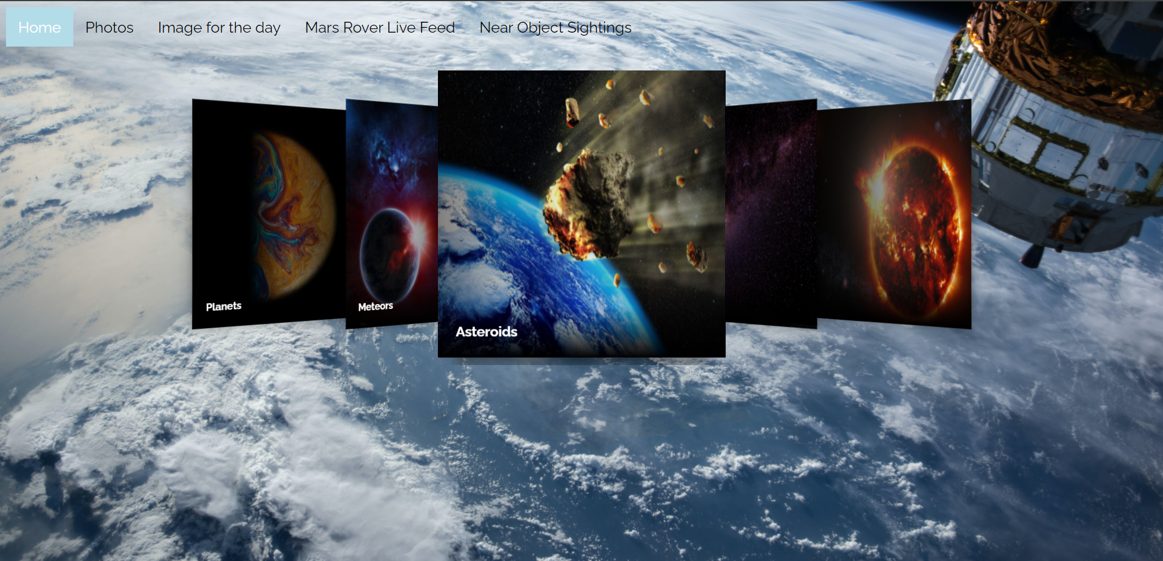

1. Photos tab

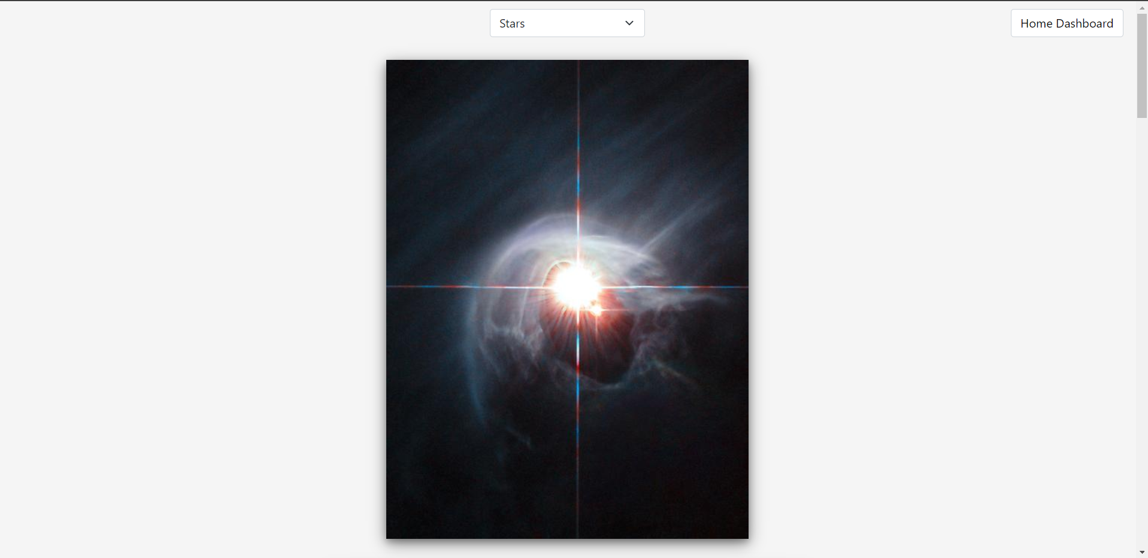

3) Image for the day

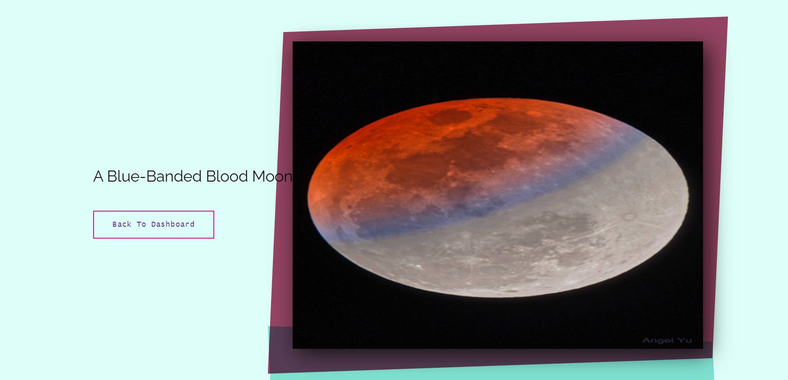

4) Mars Rover Live Feed

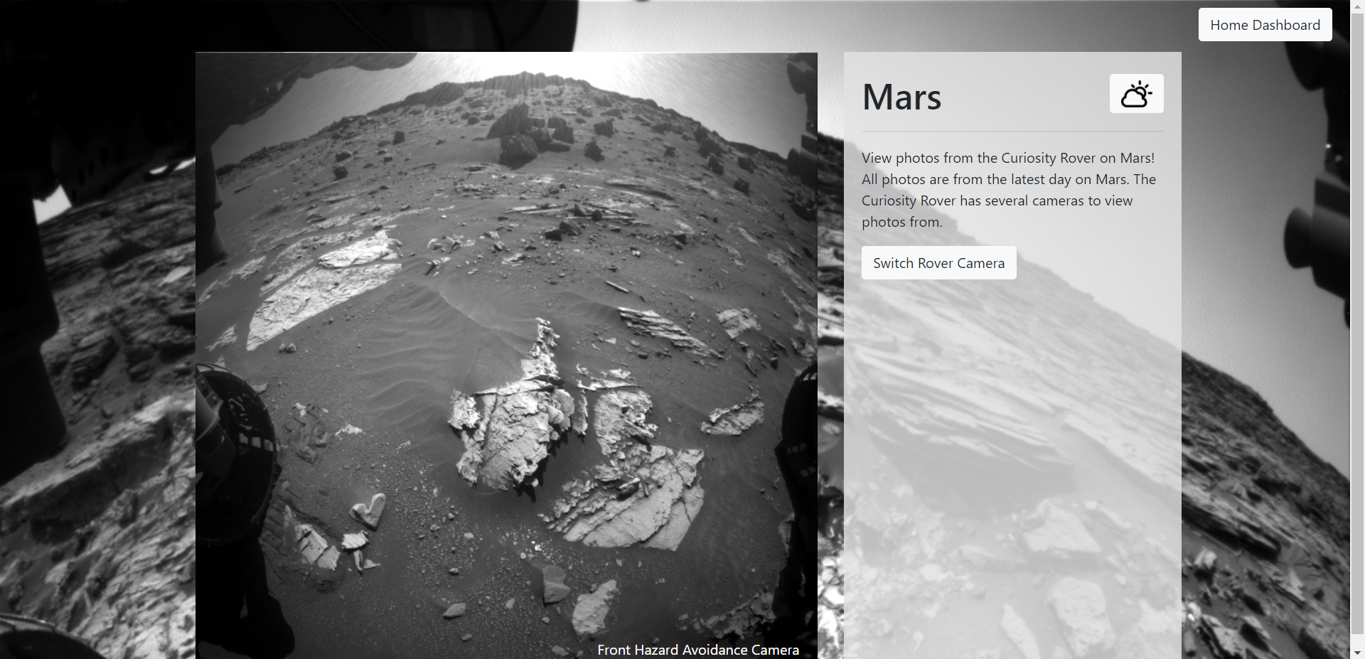

5) Near Object Sightings

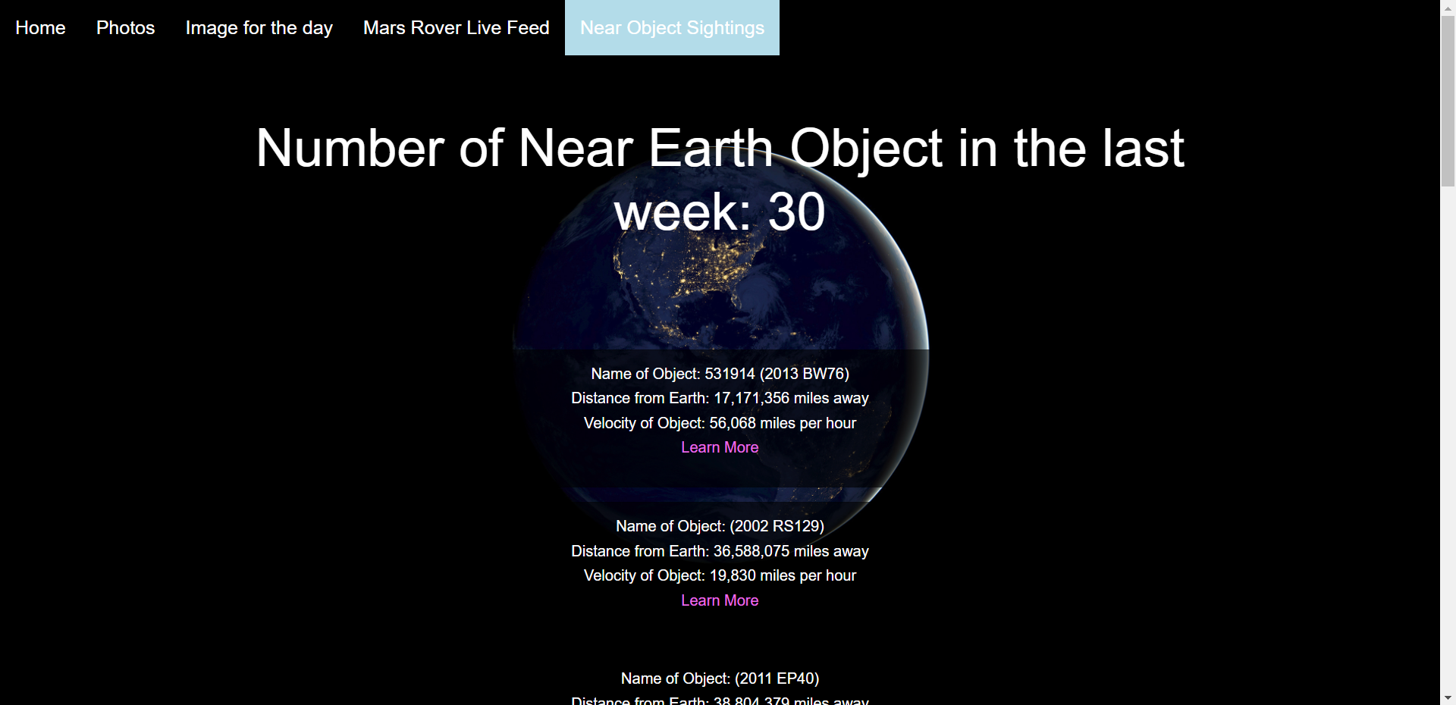

6) Planets Page

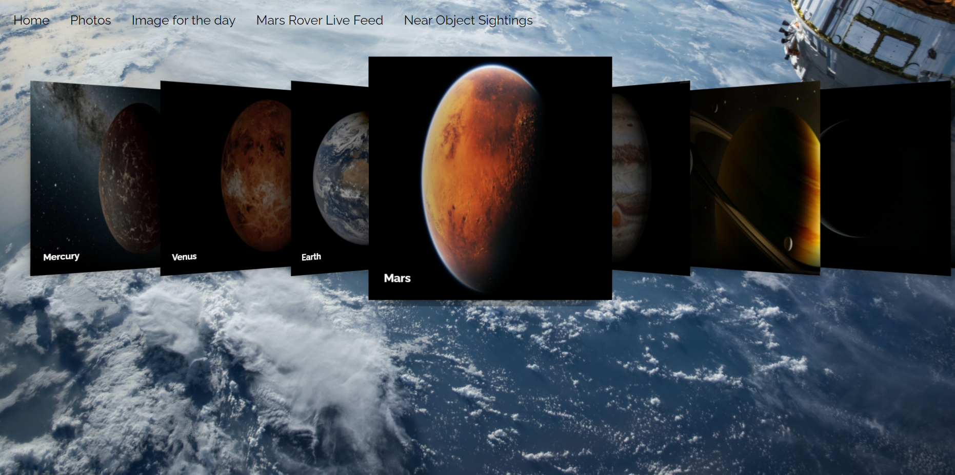

7) Each Planet

Each planet will look like this: -

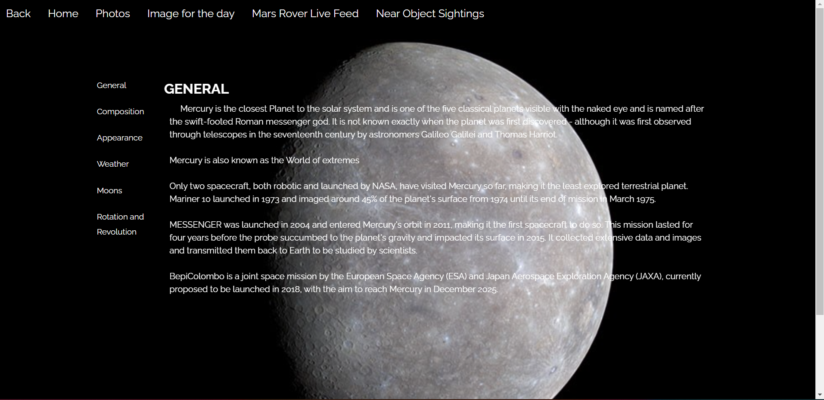

8) Meteors

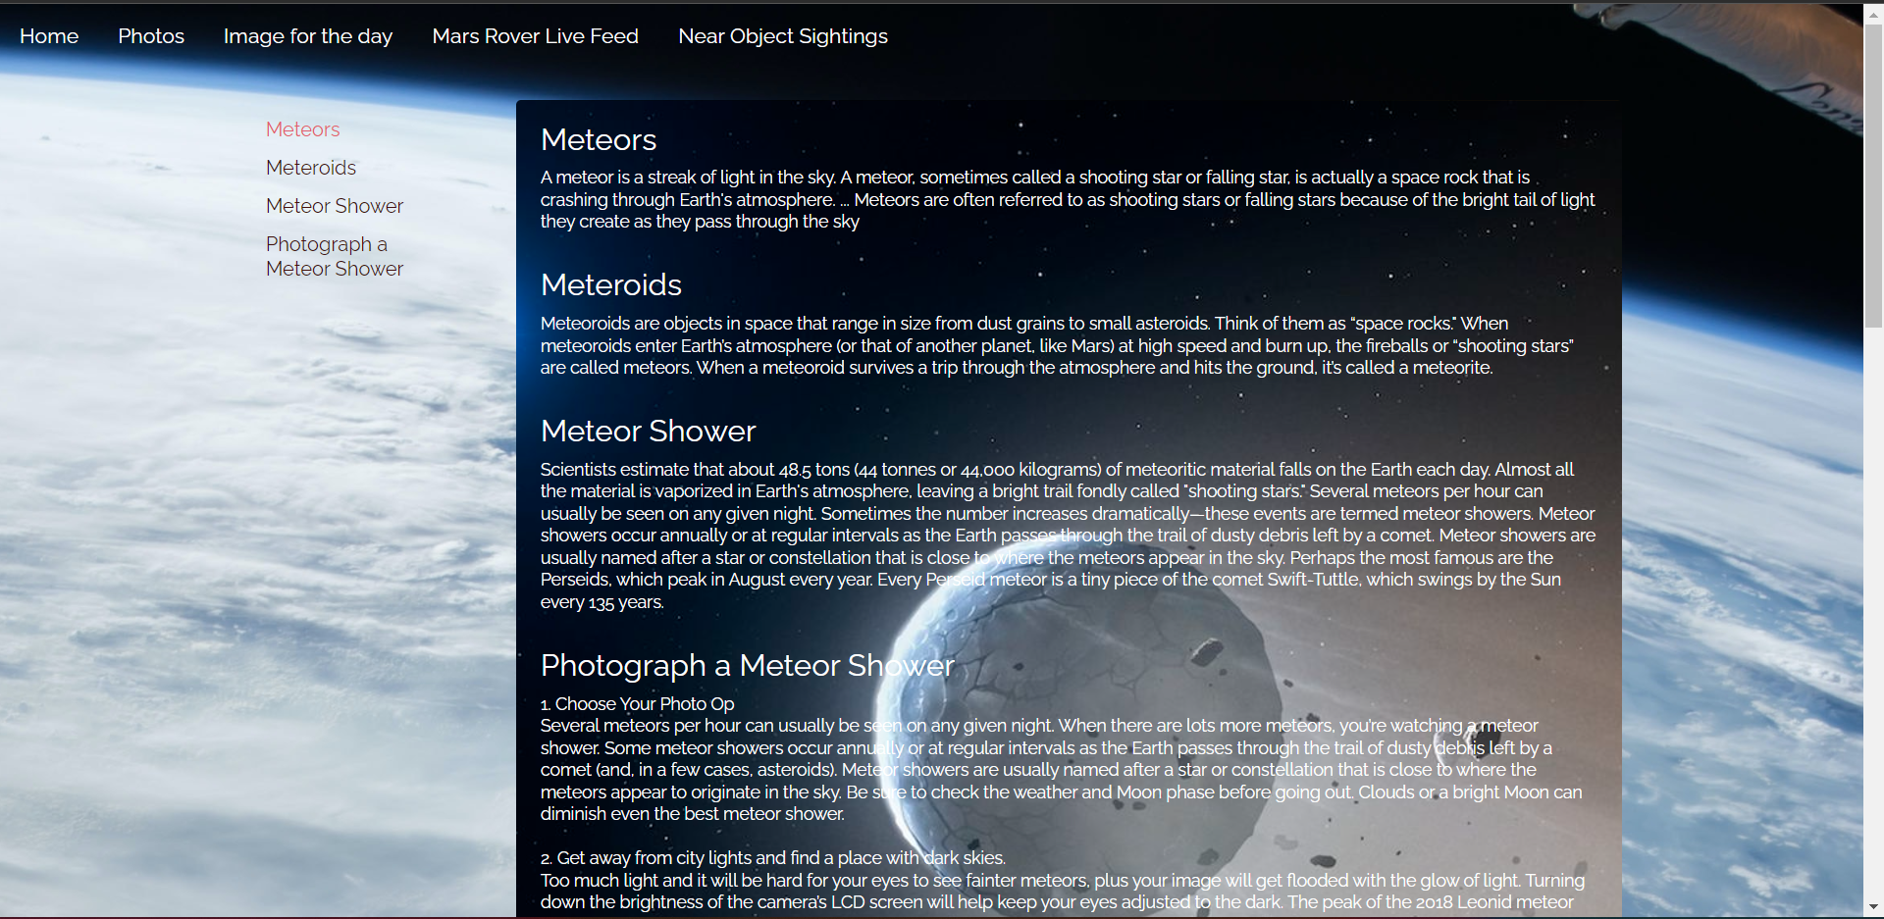

9) Asteroids

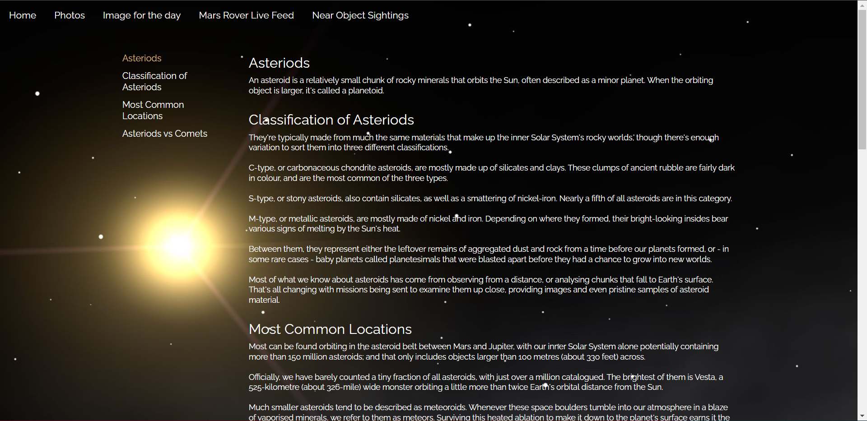

10) Galaxies

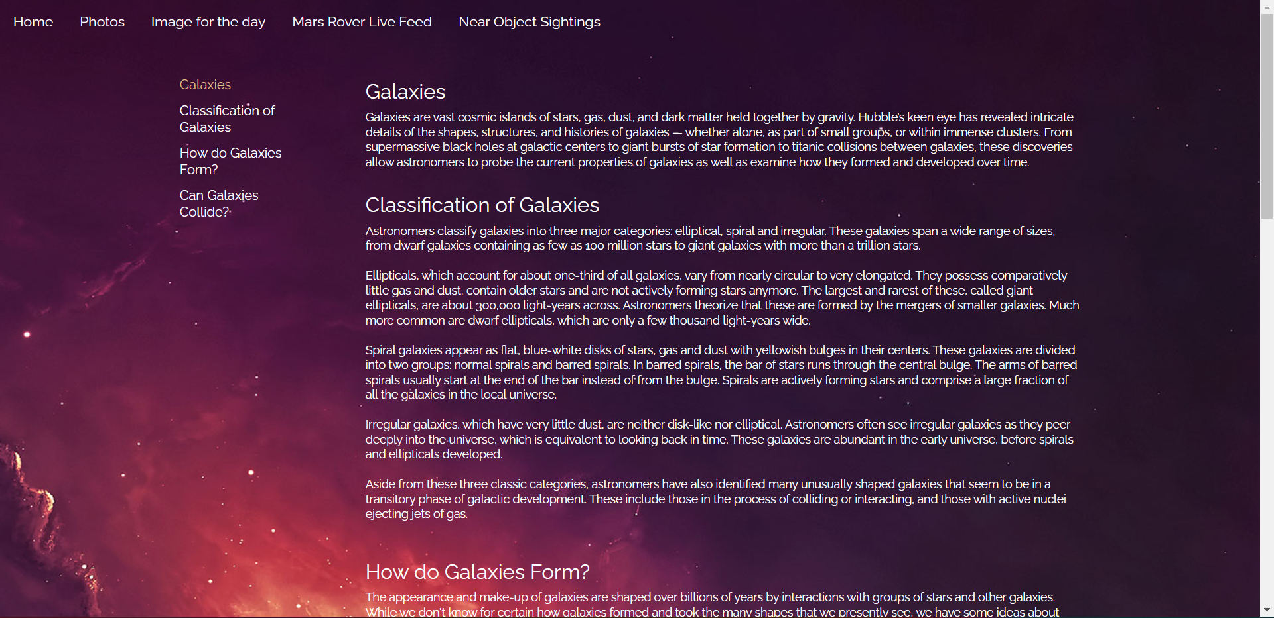

11) Sun

